Gossip - Everyone is Talking About It

Pirkei Avos (Ethics of the Fathers) 5:1
The world was created through ten statements.

#1
Real Life Cases:
(a) Your colleague is telling you about how another colleague on the team constantly comes late to work.
(b) Your best friend wants to share gossip about your mutual acquaintance.
(c) Your boss likes to talk with his employees about the private lives of others. Today he approached you.
(d) Your friend is asking about an acquaintance of yours – is he honest in business?
(e) If a particular businessman is said to have engaged in dishonest business practices, will you treat him coldly, call him a thief?
(f) An unsubstantiated report circulates that an individual who is considered needy has deliberately created a false impression of poverty in order to elicit donations. Will you cease giving him charity based on this report alone?

Questions: What is your reaction in these cases?
Why?

#2
What’s so harmful about a little gossip? Anyway, it permeates our world – it’s on television, in newspapers, and internet.

But Judaism calls gossip lashon hara, “evil speech”!
Talmud Yerushalmi (Jerusalem Talmud), Pe’ah 1:1
There are four transgressions for which one pays in this world and in the next: idolatry, sexual immorality, and murder. And lashon hara is equivalent in severity to them all.
Talmud, Sanhedrin (74a)
There are three cardinal sins in Judaism that require give up your life rather than violate.

Questions: Why should it be considered evil?
If it’s true and anyhow everyone will find out, what’s the harm?
Can lashon hara be worse than the worst of the sins?

#3
The Five Categories of Lashon Hara (Evil Speech)

1 - Gossip (rechilus)
Telling someone about what other people said about him or did to him. The information itself may be neutral, but it will cause a dispute or dislike between the parties.

2 - Lashon Hara: Derogatory or Harmful Speech
a. Derogatory speech – it might cause people to think less of the subject, and
b. Harmful speech – it might cause physical, emotional or financial harm to the subject.
Even if what he says is true!

3 - Motzi Shem Ra: Harmful or Derogatory Speech that is Untrue
Slandering or lying about someone else, a severe form of lashon hara.

4 - Ona’as Devarim: Speech That Causes Pain
The Torah looks at the pain caused by words as a real wound. This is in complete opposition to the common belief that words cannot hurt.

5 - Avak Lashon Hara (the dust of lashon hara), Speech Bordering On Lashon Hara
While the first four categories are all prohibited in the Torah, the early Torah Sages saw fit to include in this transgression anything that borders on lashon hara. The term used for this is avak lashon hara, literally, “the dust of lashon hara.”

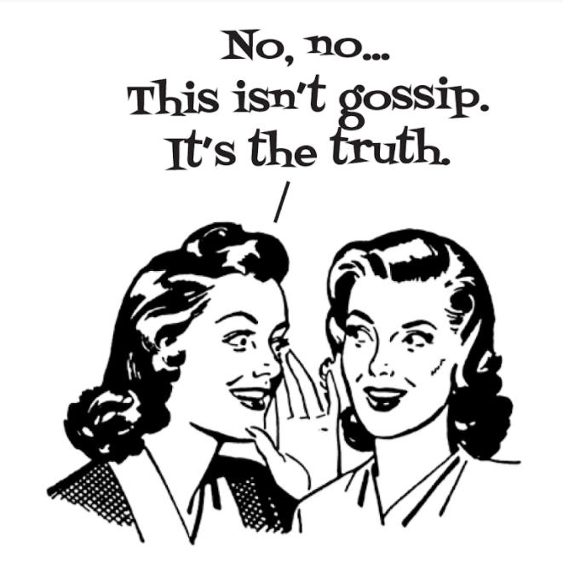
Some examples of Avak Lashon Hara are:
- “Who would have thought that So-and-so would turn out like he is today?”
- “Let’s not talk about So-and-so. I don’t want to say what happened with him.”
- Speaking positively of someone in the presence of his enemies, for this will surely cause them to start speaking negatively about the subject.
- Speaking lashon hara without malice, rather as a joke or lightheartedly.
- Similarly, one who feigns innocence, as though he were not aware of the fact that he is speaking lashon hara.

#4
Bereishis (Genesis) 2:7
And G-d formed man of dust from the ground, and He blew into his nostrils the soul of life; and man became a living soul.
Onkelos
“Man became a living soul” – He became a speaking spirit.
Rashi
“Man became a living soul” – Animal and beast too were called “living soul” [Bereishis 1:24, 30], but this soul of man is the most alive of them all, for there was added to this soul the faculties of reasoning and speech.
Kabbalah
The entirety of creation is divided into four realms or kingdoms: domem, the silent or inanimate creations; tzomeach, growing things; chai, the animal world; and medaber, the speaker—man.
Question:
Would it not have been more fitting to define man by his intelligence or spirituality?

#5
Mishlei (Proverbs) 18:21
Life and death are in the hands of the tongue.

Question: What is the meaning of this statement?

#6 Question: What is your takeaway from today's’ discussion?

